Thought Paper

Douglass Wilson
Syracuse University
IDE 621: Principles of Instruction and Learning
Dr. Robert Pusch
01 November 2025

Thought Paper
IDE 621 has provided a rigorous and reflective framework for understanding how instructional design and learning theory intersect to shape effective instruction. As a Sergeant Major with over two decades of experience in military medicine, I approached this course with a practitioner’s lens seeking not only theoretical clarity but also mechanisms for real-world application. This paper synthesizes key concepts from the course, including Merrill’s First Principles of Instruction, the three major learning theories, and my evolving stance on how these ideas inform instructional design in high-stakes, adaptive environments.
Summary of Merrill’s Five Principles of Instruction
David Merrill’s principles, problem-centered learning, activation, demonstration, application, and integration resonated deeply with my experience designing scenario-based training for medics and clinical instructors. These principles emphasize learner engagement through authentic challenges, scaffolded reflection, and iterative practice.
Problem-Centered Learning
In military medical education, learners must solve complex, real-world problems under pressure. Merrill’s emphasis on contextual relevance aligns with our use of trauma simulations and ethical decision-making drills.
Activation
Reflecting on prior deployments, I’ve seen how activating learners lived experiences whether in combat zones or clinical rotations enhances retention and judgment.
Demonstration
Modeling is central to our education. Whether it’s a senior medic demonstrating triage or an instructor modeling ethical reasoning, learners absorb more through observation than lecture.
Application
We rely heavily on hands-on practice, field exercises, moulage scenarios, and peer-led debriefs to ensure learners can translate theory into action.
Integration
Encouraging learners to reflect, teach others, and adapt skills to new contexts fosters resilience and professional growth.
Definition of Learning Theories
Learning theories offer lenses through which we understand how knowledge is acquired, processed, and constructed. IDE 621 emphasized three dominant paradigms: behaviorism, cognitivism, and social learning theory. Each has implications for instructional design, especially in environments that demand both precision and adaptability.
Instructional Design Theory
Instructional design theory translates learning theory into actionable strategies. In my work, I’ve applied elements from all three paradigms: drawing on behaviorist approaches for drilling core procedures, utilizing cognitivist frameworks to scaffold complex decision-making, and, most critically, integrating social learning principles to promote collaboration and authentic engagement. This blending of approaches enables the design of learning experiences that develop both technical proficiency and adaptive expertise, ensuring that learners are not only competent in established protocols but also prepared to navigate the uncertainties inherent in operational and clinical environments.
Behaviorism
Useful for procedural mastery, e.g., IV insertion protocols or emergency response drills. In addition to its strengths in procedural mastery, behaviorism provides a clear framework for assessing learner performance through measurable outcomes, making it especially effective in scenarios where accuracy and consistency are crucial; however, its focus on repetition and reinforcement is best complemented by other approaches when fostering adaptability and higher-level reasoning is required.
Cognitivist Design
Supports schema development, especially in clinical reasoning and diagnostic pathways. By incorporating advanced cognitive strategies such as concept mapping, metacognitive prompts, and case-based problem-solving, cognitivist design enables learners to organize information meaningfully and apply structured thinking to novel clinical scenarios. This approach is particularly advantageous when guiding practitioners through differential diagnosis or facilitating the transfer of foundational knowledge into nuanced, real-world decision-making. Cognitivist design complements other models by equipping learners with the mental tools necessary to navigate complexity and adapt established frameworks to evolving medical challenges.
Social Learning Design
Most aligned with my philosophy, leveraging collaborative learning, modeling, and reflection to build judgment and autonomy. By embedding opportunities for peer-to-peer feedback, observational learning, and scenario-based collaboration, social learning design cultivates a culture where individuals not only acquire technical skills but also develop the adaptive judgment necessary for high-stakes environments. Through intentional facilitation of group dialogue and reflective practice, this approach empowers learners to internalize best practices, challenge assumptions, and grow into autonomous professionals who are prepared to lead and innovate in unpredictable situations.
Definition of Learning from Three Theories
Behaviorism
Learning as observable behavior change through reinforcement. Effective for skill acquisition but limited in fostering critical thinking.
Cognitivism
Learning as mental schema construction. Valuable for structuring content but can be rigid in dynamic environments.
Social Learning
Learning as a socially constructed process influenced by behavior, environment, and perception. This theory best captures modeling, mentorship, and context shape learning outcomes.

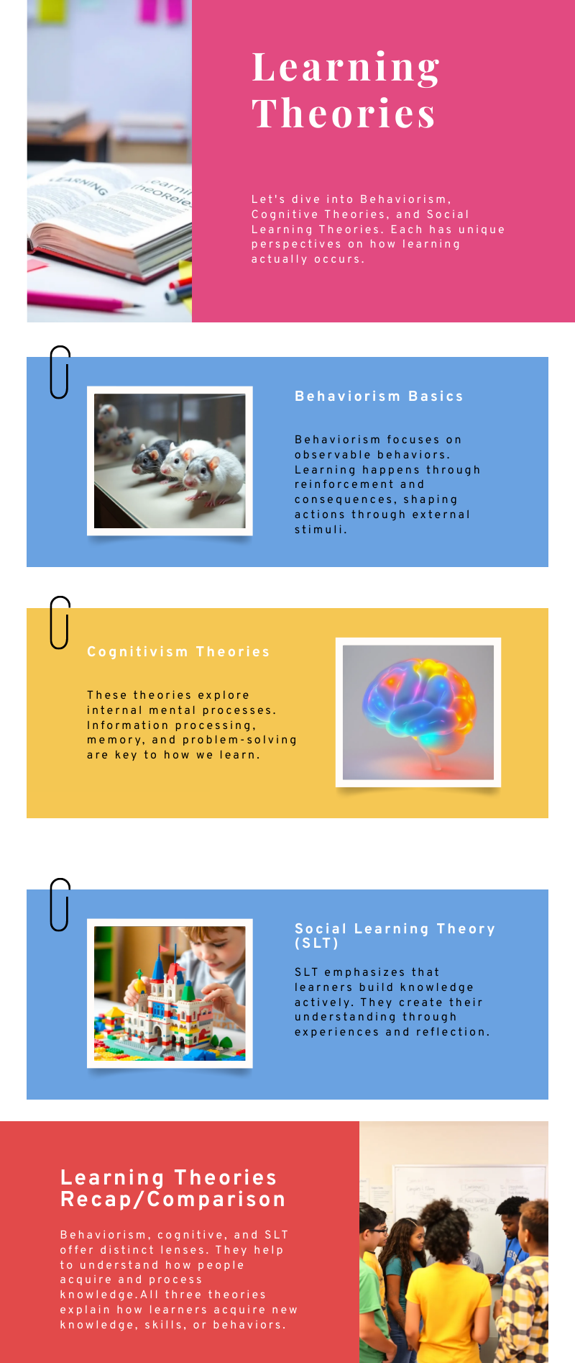
Argument for My Preferred Theory
Social Learning Theory (SLT) stands out as the most applicable to my work. Bandura’s emphasis on modeling, attention, retention, and motivation mirrors the realities of the military whether mentoring junior Soldiers or designing peer-led simulations, I’ve seen firsthand how learners construct knowledge through shared experience and reflection. Developing an observation checklist for instructor modeling helped me operationalize SLT principles. Yet, I encountered challenges, particularly in distinguishing between imitation and internalization. This prompted deeper engagement with SLT’s cognitive dimensions and reinforced the need for deliberate scaffolding and feedback. SLT also supports ethical and affective learning, critical in environments where decisions carry life-or-death consequences. It encourages learners to take ownership, reflect on their values, and adapt to evolving contexts. For these reasons, SLT is not just a theory I prefer, it’s a framework I live by.
Why the Other Theories Fall Short
While behaviorism, with its focus on observable outcomes and reinforcement, can efficiently shape basic competencies, it fails to address the critical nuances. Learners must navigate ambiguity, exercise judgment under pressure, and internalize the values that guide ethical decision-making in complex situations. The absence of attention to affective and moral growth limits behaviorism’s utility in for me in preparing Soldiers for environments where technical proficiency alone is insufficient, and where the ability to reason through dilemmas and respond with empathy is just as essential as mastering protocols.
While cognitivism provides a solid organizational framework for instructional content, its emphasis on structured mental processes can inadvertently limit the flexibility required for dynamic problem-solving and innovation, especially in fast-changing environments. In contrast, Merrill’s principles, with their focus on authentic engagement and iterative practice, better support the development of adaptive expertise among Soldiers by encouraging learners to apply knowledge in varied scenarios and reflect on their experiences, thereby bridging the gap between theoretical understanding and practical competence.
Conclusion
IDE 621 has deepened my understanding of how learning theories inform instructional design. It has challenged me to refine my tools, question assumptions, and align theory with practice. As I continue mentoring Soldiers and transforming learning environments, I will carry forward the principles of SLT modeling not just skills, but the professional judgment and ethical clarity our learners need to thrive.

